MATHEMATICS TEST

Instructions: Circle the letter of the response that you believe is the correct answer to that question.

- Chris drove 100 kilometers from San Francisco to Santa Cruz in 2 hours and 30 minutes. What computation will give Chris’ average speed, in kilometers per hour?

a. Divide 100 by 2.5
b. Divide 100 by 2.3
c. Multiply 100 by 2.5
d. Multiply 100 by 2.3

A flower shop delivery van traveled these distances during one week: 104.4, 117.8, 92.3, 168.7, and 225.6 miles. How many gallons of gas were used by the delivery van during this week?

What other information is needed in order to solve this problem?

a. The average speed traveled in miles per hour
b. The cost of gasoline per gallon
c. The average number of miles per gallon for the van
d. The number of different deliveries the van made

- A shipping company has 25 offices that shipped 60,000 packages last week. The offices were open 6 days and used 80,000 kilowatt-hours of electricity. Which pieces of information given above are necessary to find the average number of packages shipped per day last week?

a. The number of offices and the number of packages
b. The number of packages and the amount of electricity used
c. The number of packages and the number of days open during the week
d. The number of days open during the week and the amount of electricity used

- Find the x- and y-intercepts of the graph for the following equation: y = x³ – 4x

a. x-intercept: (2,0), (0,0), (4,0)
y-intercept: (0,1), (0,2)
b. x-intercept: (0,0), (2,0), (-2,0)
y-intercept: (0,0)
c. x-intercept: (0,0), (2,0), (-2,0)
y-intercept: (0,1)
d. x-intercept: (3,0), (9,0)
y-intercept: (0,2), (0,-2)

- If n is any odd number, which of the following is true about n + 1?

a. It is an odd number
b. It is an even number
c. It is a prime number
d. It is the same number as n – 1

- The table below shows the flight times from San Francisco to New York. Which flight takes the longest?

Leave S.F. Time | Arrive N.Y. Time
8:30 A.M.  12:00 noon  3:30 P.M.  9:45 P.M. | 4:50 P.M.  8:25 P.M.  11:40 P.M.  5:50 A.M.

a. The flight leaving at 8:30 A.M.
b. The flight leaving at 12:00 noon
c. The flight leaving at 3:30 P.M.
d. The flight leaving at 9:45 P.M.

- If a is a positive number and b is a negative number, which expression is always positive?

a. a – b
b. a + b
c. a × b
d. a ÷ b
1
2
1
4
1
8
1
16
1
1024
+
+
+
+
+
…
- Based on the pattern in the problems below, what is the sum of ?
1
2
1
4
3
4
+
=
1
2
1
4
1
8
1
16
15
16
+
+
+
=
1
2
1
4
1
8
7
8
+
+
=
1
2
1
4
1
8
1
16
1
32
31
32
+
+
+
+
=

1001

1024
1023

1024

1010

1024

1025

1024

a.

b.

c.

d.

- Expand the following logarithmic expression: In √(3x +2)

a. In (3x + 2)
b. In 3x + In2
c. 2 In (3x +2)
d. ½ In (3x + 2)

- Which is the best estimate of 326 × 279?

- 900
- 9,000
- 90,000
- 900,000
- Marcus plans to buy a CD that has a regular price of $13.99. It is on sale for 10% off, but Marcus will have to page 7% sales tax. Which is the MOST reasonable estimate of the total cost of the CD including tax?

a. $12.50
b. $13.50
c. $14.50
d. $15.50

- The temperature on a mountain was 7°F at 6:00 p.m. By 8:00 p.m., the temperature was 0°F. If it continued to drop at about the same rate, which is the BEST estimate of the temperature at 11:00 p.m.?

a. –20°F
b. –14°F
c. –10°F
d. –9°F

- The table below shows the number of visitors to a natural history museum during a 4-day period. Which expression would give the BEST estimate of the total number of visitors during this period?

Day | Number of Visitors
Friday  Saturday  Sunday  Monday | 597  1115  1346  365

a. 500 + 1100 + 1300 + 300
b. 600 + 1100 + 1300 + 300
c. 600 + 1100 + 1300 + 400
d. 600 + 1100 + 1400 + 400

- Find the following limit: lim (4x² + 3)
x → 2

a. 3
b. 19
c. 4x² + 3
d. 11

- Sally paid $1.89 for 5 plums. About how many plums would she get for $10?

a. 4
b. 5
c. 10
d. 25

- The winning number in a contest was less than 50. It was a multiple of 3, 5, and 6. What was the number?

a. 14
b. 15
c. 30
d. It cannot be determined.
- Lia used the following process to find the slope of the line described by the equation 3y + 5x = 12.

Step 1: Subtract 5x from each side. | 3y = –5x + 12
Step 2: Divide each side by 3. | 5  3  y = – x + 4  5  3
Step 3: The slope of y = mx + b is m. | Slope is –

According to Lia’s method, which of the following expressions gives the slope of the line described by the equation ay + bx = c?
a

b
a. –
a

b

b.
b

a

c. –
b

a

d.
– √3
2
- Solve the following equation: sin θ =
4π

3
5π

3
a. and

b. 2π
4π

3

c. 2π and
π

2

π

6

d. and

- The table below shows values for x and the corresponding values for y. Which of the following represents the relationship between x and y?

x | y
21 | 3
14 | 2
28 | 4
7 | 1

a. y = x / 7
b. y = 7 x
c. y = x – 6
d. y = x – 18
Len runs a mile in 8 minutes. At this rate, how long will it take him to run a 26-mile marathon?

Which of the following problems can be solved using the same arithmetic operations that are used to solve the problem above?

a. Len runs 26 miles in 220 minutes. How long does it take him to run each mile?
b. A librarian has 356 books to place on 18 shelves. Each shelf will contain the same number of books. How many books can the librarian place on each shelf?
c. A cracker box weighs 200 grams. What is the weight of 100 boxes?
d. Each basket of strawberries weighs 60 grams. How many baskets can be filled from 500 grams?
- Find the derivative of the following expression: f(x) = x³ – 4x + 5.

a. f '(x) = x³ + 5
b. f '(x) = 2x – 4
c. f '(x) = 3x² – 4
d. f '(x) = x³ – 2x + 5x
3

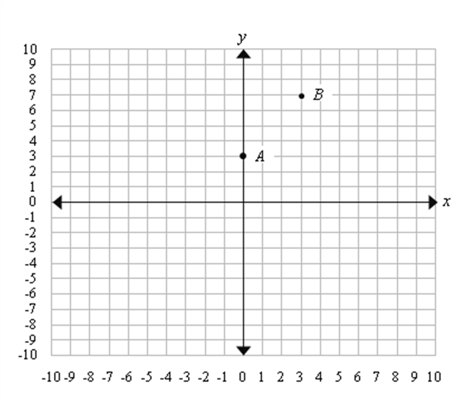
- If a line passes through points A and B shown below, approximately where does the line cross the x-axis?

a. Between –3 and –2
b. Between 0 and –1
c. Between 0 and 1
d. Between 1 and 2

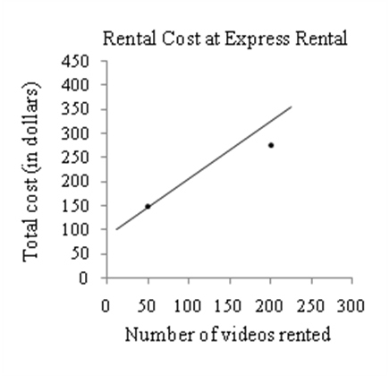
- Using the line of best fit shown on the scatterplot below, which of the following best approximates the rental cost per video to rent 300 videos?

a. $3.00
b. $2.50
c. $2.00
d. $1.50

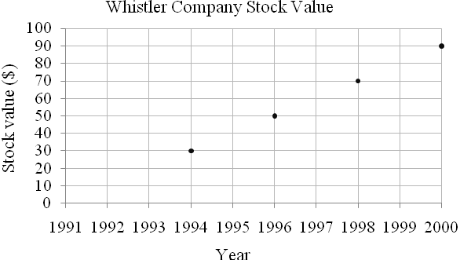
- The graph below shows the value of Whistler Company stock at the end of every other year from 1994 to 2000. From this graph, which of the following was the most probable value of Whistler Company stock at the end of 1992?

a. –$10
b. $1
c. $10
d. $20

- Mia found the area of this shape by dividing it into rectangles as shown below.

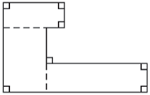

Mia could use the same method to find the area for which of the following shapes?


a.

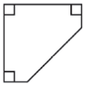
b.

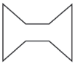
c.

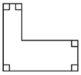
d.

MATHEMATICS TEST

Answer Key

- a
- c
- c
- b
- b
- b
- a
- c
- d
- c
- b
- c
- c
- b
- d
- c
- c
- a
- a
- c
- c
- a
- d
- c
- d

